Android history

- Andy rubin founded Android incorporation in polo alto, california ,U.S. Oct 2003.
- The key employees of Android incorporation are Andy rubin,Rich miner,Chris white,Nick sears.
- Google Incorporation hired Android incorporation 17,Aug,2005 .
- Android originally intended for camera but Shifted to smart Phones.(Because low market of camera)
- Google announces the development of android operating system in 2007
- First Beta released in Nov,5,2007.
- The first commercial version, Android 1.0, was released on September 23, 2008.
- HTC launched the first Android mobile in 2008 (HTC Dream).
- Android logo look like combination of Robot+ green bug,created by "Irina Blok".

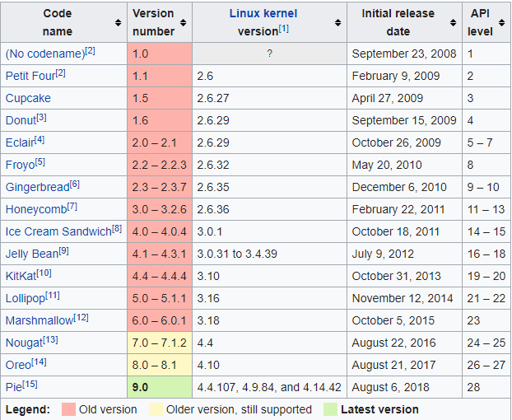

Android Architecture

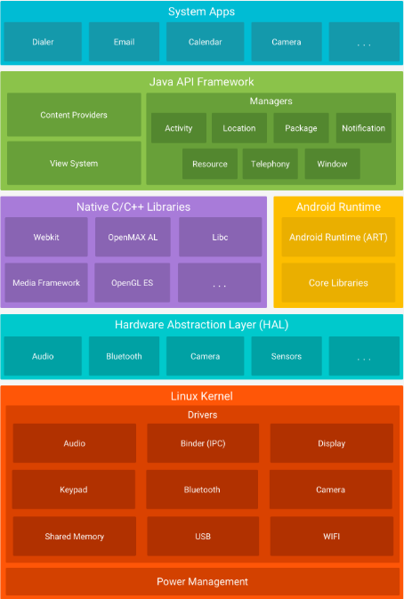
https://developer.android.com/guide/platform/

Activity Launch Modes

Activity Launch mode is an instruction for android OS which specifies how the activity should be launched.

- The activities are arranged in a stack(the back stack)—in the order in which each activity is opened.
- push and pop operations -(last in, first out).
- "main" activity for that app opens as the root activity in the stack.

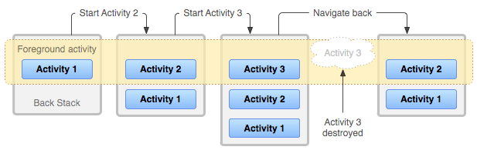
https://developer.android.com/guide/components/activities/tasks-and-back-stack

- You can define different launch modes in two ways:

Using the manifest file:
When you declare an activity in your manifest file, you can specify how the activity should associate with tasks when it starts.
There are four launch modes for activity. They are:
- Standard
2. singleTop
3. singleTask
4. singleInstance

Syntax:
<activity android:launchMode = [“standard” | “singleTop” | “singleTask” | “singleInstance”] ../>

Example :

<activity android:name=".MainActivity"
android:launchMode="singleTop">
</activity>

Using Intent flags:
When you call startActivity(), you can include a flag in the Intent that declares how (or whether) the new activity should associate with the current task.
- FLAG_ACTIVITY_NEW_TASK (single task)
- FLAG_ACTIVITY_SINGLE_TOP (single top)
- FLAG_ACTIVITY_CLEAR_TOP (single instance)

Example:

Intent i = new Intent(this, Sample.class);
i.setFlags(Intent.FLAG_ACTIVITY_CLEAR_TOP);
startActivity(i);

Reference websites:
https://developer.android.com/guide/components/activities/tasks-and-back-stack
https://android.jlelse.eu/android-activity-launch-mode-e0df1aa72242

